IMPACT OF STANDARDIZATION ON PRODUCTION PROCESSES DESIGN

Peter Kováč ¹ – Juraj Maly ² – Vladimír Velky ³
Abstract: Standardization is a poorly understood discipline in practice. While there are excellent studies of standardization as an economic phenomenon, or as technical a phenomenon, or as a policy initiative, most of these are ex post facto and written from a dispassionate academic view. They are of little help to practitioners who actually are using and creating standards. The arena in which standardization is played out is reasonably large. Nearly every industry is affected by standards, some more so than others.
Keywords: standardization, normalization, production process, design

1 INTRODUCTION
Standardization is a systematic, dynamic process of selection, unification and effective stabilization of individual variant solutions, processes, input elements and their combinations, output elements and their combinations, activities and information in process management of enterprises or sections thereof. The goal is to reduce diversity, chances in controlled processes. An important goal is also to ensure clarity of interpretation of decisions, approaches and elements adopted. [1, 2]
2 PRINCIPLES OF STANDARDIZATION
Object of standardization activity in engineering production can be all elements of complex structure of objects and processes of engineering production.
The added value of standardization activity depends on the principles by which the individual standards are done. [6, 7]
There are several positive benefits of standardization:
- In organizing production, technical, economic and commercial, personnel and other activities.
- In the unification of information and in unequivocal verbal capacity thereof.
- In intensifying production and increasing the level of its specialization.
- In more efficient use of resources.
- In higher economic efficiency of enterprises and especially production processes.
- In higher security and reliability of implemented processes, and so on.

Common principles are: complexity, progressivity, purposefulness, maximum resource economy, work safety priority, active feedback, optimal quality, optimal number of species, uniqueness (Tab. 1). [8, 9]

Table 1. Basic principles of standardization
Principle | Description
Principle of complexity | This principle requires detailed and versatile analysis of possible links of the established standards or methods of their creation with the recognition of
Principle of progressivity | Requirement of one-way acting of standards to qualitative parameters of standardization subjects. Adopted standard should not be a brake on progress
Principle of purposefulness | There is a need for a close link between the creation and innovation of
Principle of maximum resource efficiency | Maximum resource efficiency is the central principle of any standardization activity. For methodological reasons, it is

Standardization activity is ensured by [10, 11]:
- The arrangement (systemization) − the state of chaos and disorder is changed into the state of organization.
- Unification − leads to unified interpretation of terms, names, symbols.
- Interchangeability − creates prerequisites for the exchange of one component for another one, one aggregate for another one, etc..
- Optimal quality and product differentiation− maintain the optimum of these values ​​by both, manufacturers as well as consumers.
- Production guidelines − direct production in the direction of the most progressive methods and structures.
- Production economization − increases the proportion of higher production types, increases seriality and reduces demands on equipment of the machines.
3 NORMALIZATION ACTIVITIES
Normalization activities are developed by several related methods (Tab. 2). [9, 12]
Standardization activities, developed at different stages of scientific and technological development, have led to standardization systems, characterized by the target focus. Standardization systems are of a special nature, corresponding to two different standardization eras [13]:
- The system based on simplification, standardization and specialization represents the first generation of standardization enabled development of various methods of standardization, in particular type specification and unification, namely in the area of ​​design and technology.
- System based on standardization, specialization and automation. The system represents the II. generation of standardization specialization, to specify the bases for the development of automation of production.
4 LINKS OF STANDARDIZATION
The success of standardization is mainly due to its comprehensive solution. Uniform areas of standardization are only relatively isolated activities because the production process creates the necessary context between them. For methodological and personnel safety, the following stages are generally required of enterprises [14]:
- Standardization of the management process.
- Standardization of input elements of the production process.
- Standardization of activities in the production process.
- Standardization of the consumption and the use of production factors.
- Standardization of combinations in the operational management of production.
- Standardization of outputs elements of the production process.

The relations between the basic methods of standardization are shown in Fig. 1.
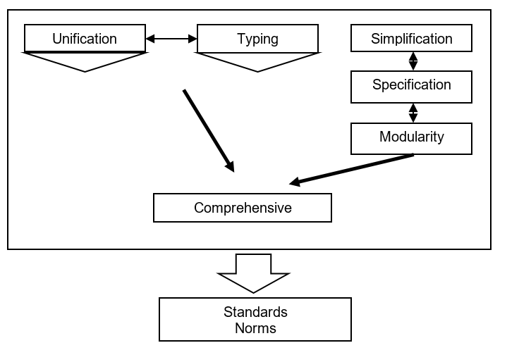
Figure 1. Links between the basic methods of standardization [9]

Technical standards are documents that contain technical specifications or other determining criteria used as rules, guidelines or definitions of properties to ensure that materials, products, production processes, services, and so on are fit for the given purpose.
5 STANDARDIZATION IN PRODUCTION PROCESSES
In addition to component properties that directly determine their activities, the properties that are crucial for the technology of their production are examined, too. The following aspects are examined in particular [15]:
- The final function of the component.
- Functional features of the component.
- Design-technological features of the component.
Another important manner of how serial production can be increased is the application of standardization of technological processes, i.e. the development of technological procedures for different design groups and technologically similar product parts. All of this positively impacts the production unit costs. Due to standardization of technological processes, the number of production batches is higher and a higher-level type of production is achieved. [16]
The following procedure is typical for establishing a technological process type [16]:
- Classification of components (elementary surfaces).
- Design of type-specific technological process (operations).
- Determination of individual stages of technological processes.
- Draft of the type-representative technological process.
- Transfer of type-specific technological instruction to a particular component.

Type-specific technological processes are applied in bulk and large-scale production and, in some cases, in serial production with a steady nomenclature.
6 CONCLUSION
A standard is that which has been selected as a model to which objects or actions may be compared. Standards for industry may be devices and instruments used to regulate colour, size, weight, and other product attributes, or they may be physical models.
ACKNOWLEDGEMENTS
This work has been supported by the Scientific Grant Agency of the Ministry of Education of the Slovak Republic (KEGA ……. and VEGA ......).
REFERENCES
According to the APA

- Majernik, M., Daneshjo, N., Chovancová, J., & Sanciova, G. (2017). Design of integrated management systems according to the revised ISO standards. Polish Journal of Management Studies, 15(1), 135-143.
- https://link.springer.com/article/10.1007/s10799-015-0215-7

AUTHORS ADDRESSES
¹Ing. Peter Kováč, PhD.
Technical University of Kosice
Faculty of Mechanical Engineering
Department of Industrial and Digital Engineering
Park Komenskeho 9, 042 00, Kosice
Slovak republic
e-mail: peter.kováč@tuke.sk

² Ing. Juraj Maly, PhD.
Technical University of Kosice
Faculty of Mechanical Engineering
Department of Industrial and Digital Engineering
Park Komenskeho 9, 042 00, Kosice
Slovak republic
e-mail: juraj.maly@tuke.sk

³ doc. Ing. Vladimír Velky, PhD.
Technical University of Kosice
Faculty of Mechanical Engineering
Department of Industrial and Digital Engineering
Park Komenskeho 9, 042 00, Kosice
Slovak republic
e-mail: vladimir.velky@tuke.sk

